Ethan Daugherty

SNHU

CS-340-T4528

1-3 Assignment: Intro to MongoDB

03/06/2022

**Intro to MongoDB**

In this assignment, you will verify your access to MongoDB by using the Linux shell prompt to access the mongo shell. You will be asked to run different administrative queries on a database of email documents, enron.json, which has been uploaded into Mongo for you. Follow the steps outlined below to complete these tasks.

1. Begin by logging into the Virtual Lab (Apporto) and accessing the terminal application. Use the [Mongo in Apporto (Virtual Lab) Tutorial PDF](https://snhu.brightspace.com/content/enforced/1009040-CS-340-T4528-OL-TRAD-UG.22EW4/course_documents/CS%20340%20Mongo%20in%20Apporto%20(Virtual%20Lab)%20Tutorial.pdf?_&d2lSessionVal=a1Cynp4a49qhGdFTAlvAZmvcN&ou=1009040) to help with this task.

1. First, you must **verify access to the environment** by starting up MongoDB and the mongo shell. In the terminal application, bring up the Linux shell prompt and do the following:
   * **Execute the mongo command to start the mongo shell**. This will bring up the mongo shell prompt.
   * Take a **screenshot** of the whole terminal window to verify your presence in the mongo shell. **All of your screenshots *must* include your username, which is at the top of your terminal window.**

Tip: It is important to make sure that your screenshots are clear and large enough to be easily read. Refer to this [Use Snipping Tool to Capture Screenshots](https://support.microsoft.com/en-us/help/13776/windows-10-use-snipping-tool-to-capture-screenshots) guide for help with taking screenshots.

1. You have been provided with a preloaded database containing email documents. Using the database provided, execute the following administrative commands:
   * **Load the database by executing the following**:
   * cd /usr/local/datasets
   * /usr/local/bin/mongod_ctl start-noauth  
       
      #**** copy the port number given in the output, example +++ Starting MongoDB

(NOAUTH): Port=27908 *****  
 #**** be sure to replace the ##### with the port number you were given  
  
 mongoimport --port ##### --db enron --collection emails ./enron.json

* + **Retrieve a document from the collection** by executing the following commands in the mongo shell. Take a screenshot to verify your execution of these commands.
  + show dbs #lists directory of databases  
    Text

    Description automatically generated
  + use enron #this sets db to the enron database  
    Text

    Description automatically generated
  + show collections #lists directory of collections  
    Text

    Description automatically generated
  + db.emails.findOne() #retrieves a document from the emails collection  
    Text

    Description automatically generated
  + **Execute the command to find the size of a single document** of your choosing from the enron database. Refer to your textbook if you need help constructing this command. Take a screenshot to verify your execution of this command.  
    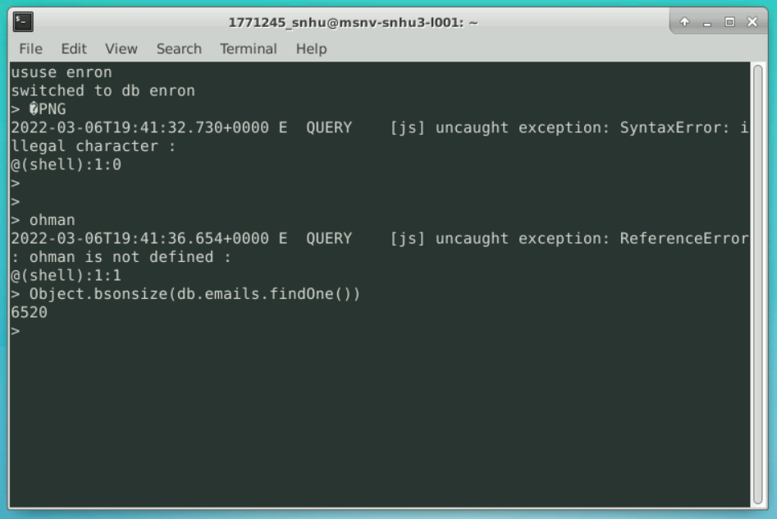
  + **Execute the command to find the size of the collection of documents** in the enron database. Refer to your textbook if you need help constructing this command. Take a screenshot to verify your execution of this command.  
    Text

    Description automatically generated